Eng 9 Notes on Conflict
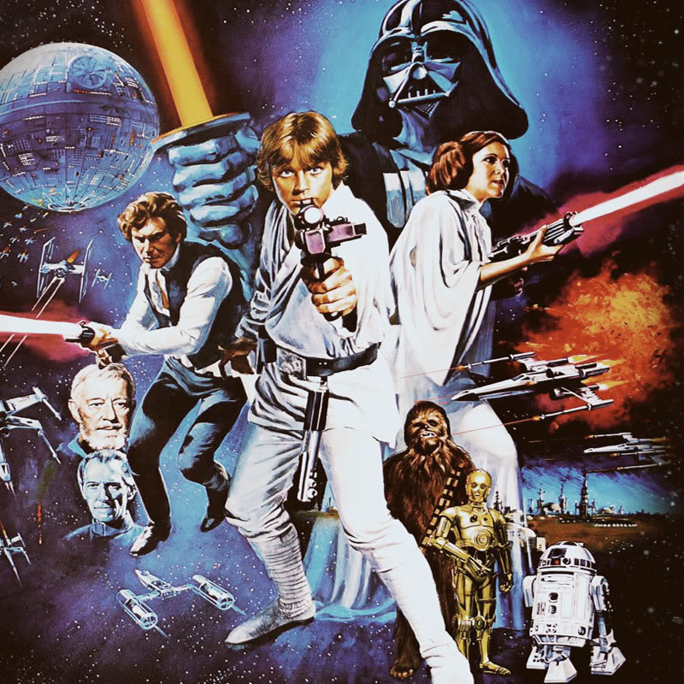

CONFLICT- A Problem or issue between 2 characters, or a character and a force.
Stories usually have
- A number of minor conflicts (called complications), and
- At least one major conflict that leads to a climax and resolution (see chart for plot)

Conflicts are usually classified as

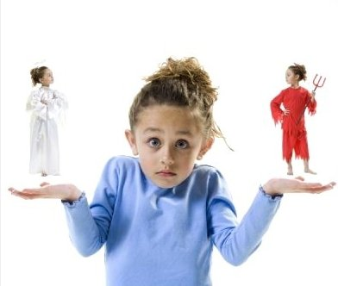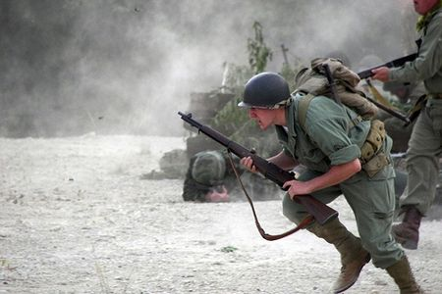

Internal Conflicts External Conflicts
-Problems are inside the person -Problems that come from outside the person
Examples include Examples include
*emotional conflicts *social conflicts
*psychological conflicts *physical conflicts
*Illnesses *anything where the character faces a problem from without

Another way of classifying conflicts is the method of…

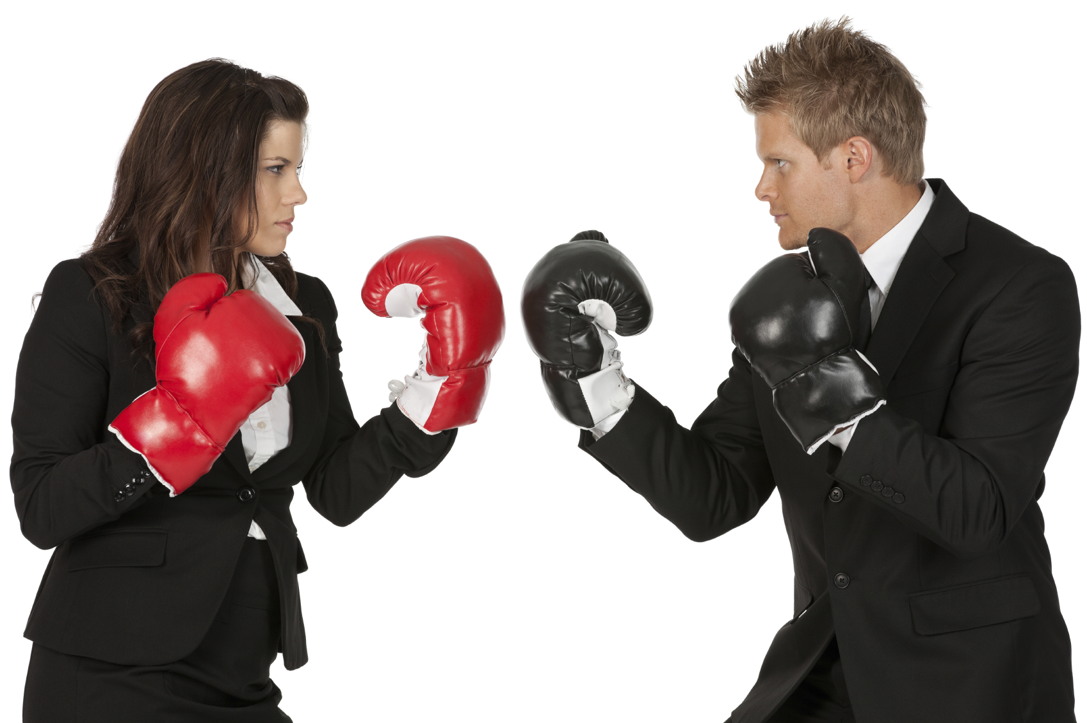 Character vs Character
(a one on one fight, argument, or problem)

 Character vs Self
(when a character battles himself in some way)
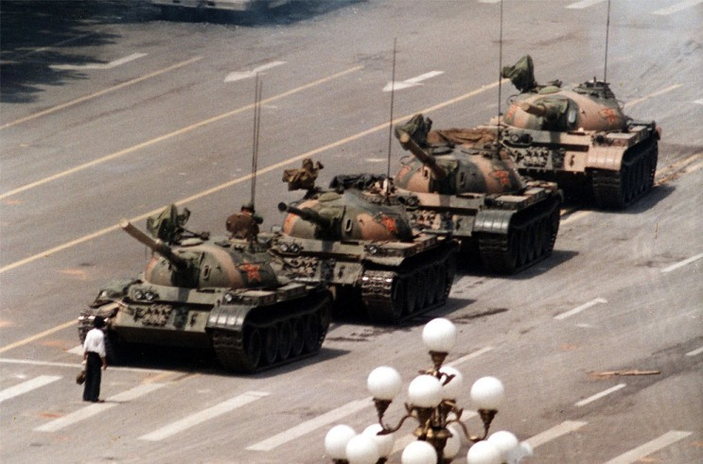 Character vs Society
(when a character must face 2 or more people; or rules)
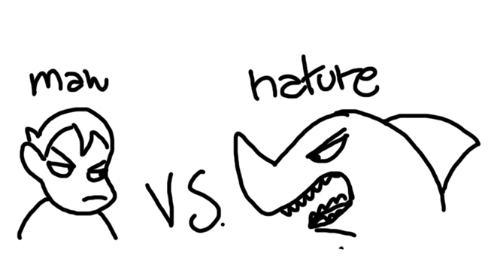 Character vs Nature
(environment) when characters battle land, animals, weather,
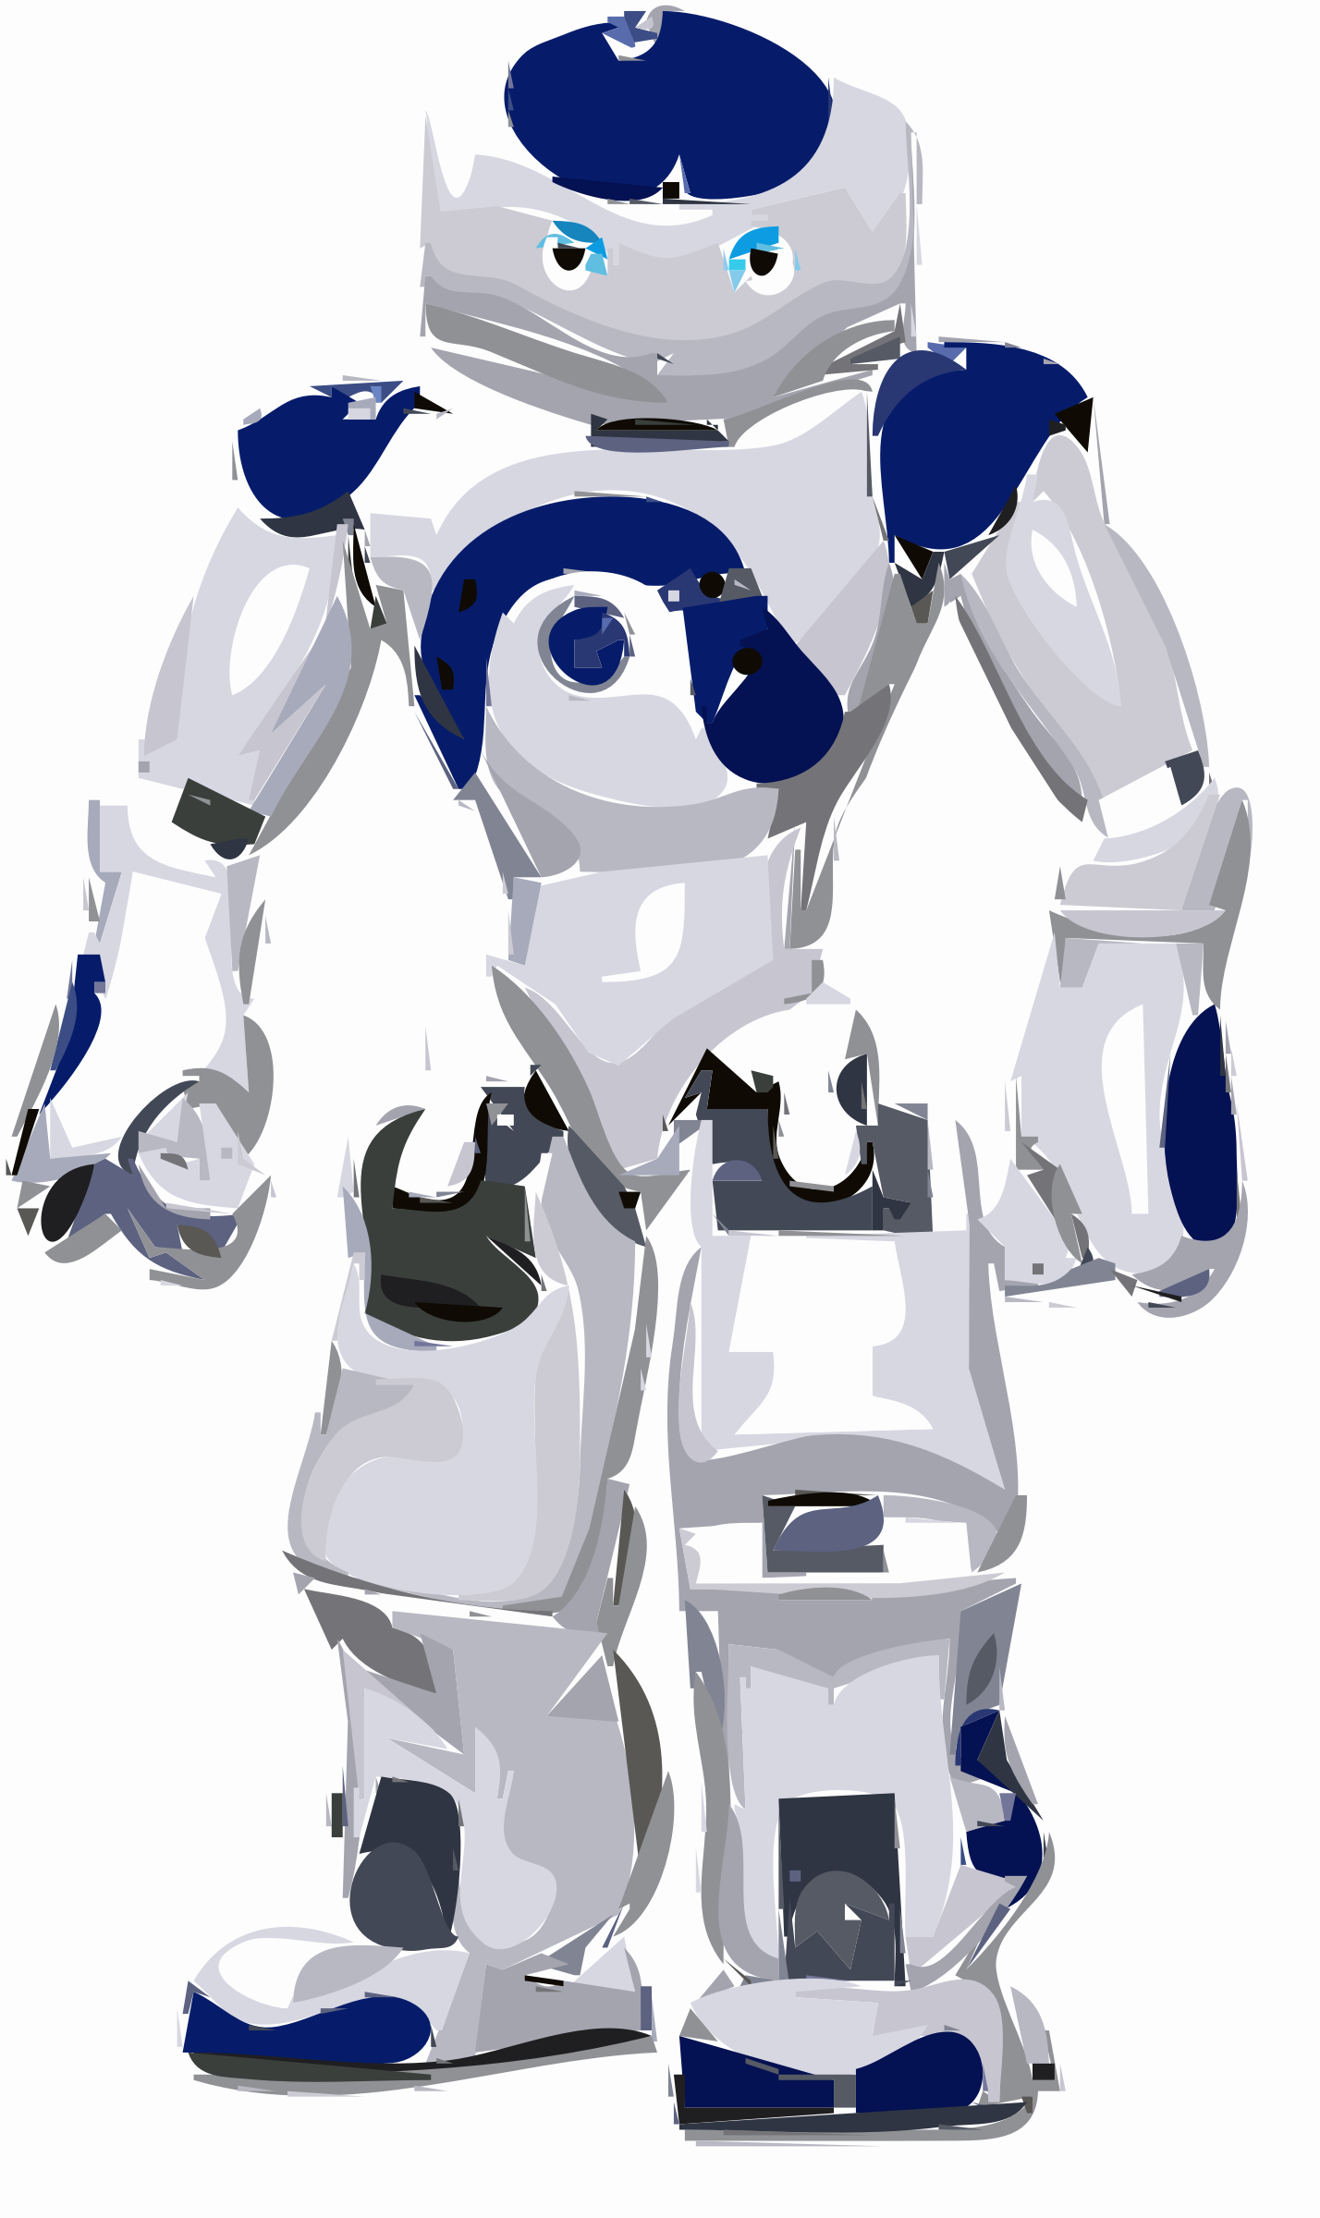 Character vs Technology
robots, computers, software, AI
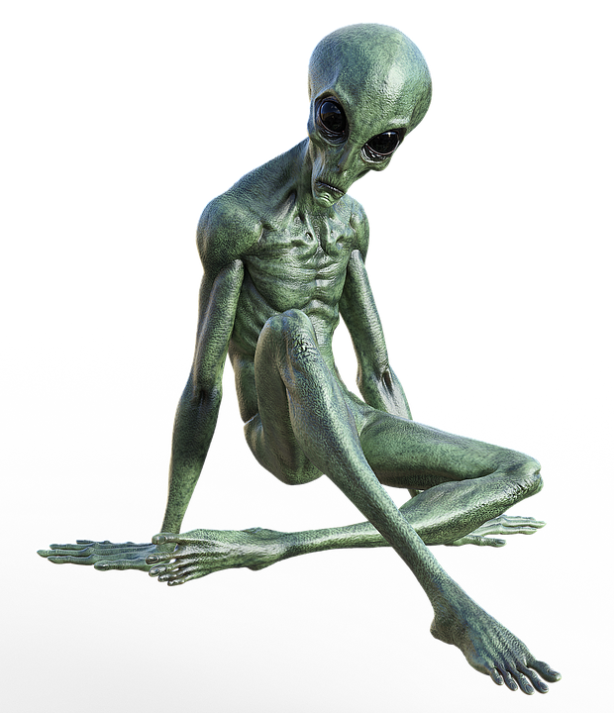Character vs. Supernatural
gods, superheroes, spirits, ghosts, aliens etc…

One more type of conflict is a dilemma
Dilemma: a conflict where the character must choose between two undesirable options, neither having a good outcome.

